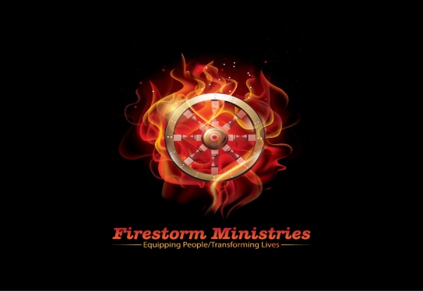
COVID-19 Safety Acknowledgement
Liability Waiver and Release of Claims
Ephesians 4:12 “For the equipping of the saints, for the work of the ministry…”

COVID-19 SAFETY INFORMATION:
While participating in events held or sponsored by Firestorm Ministries (FSM) “social distancing” must be practiced and face coverings worn at all times to reduce the risks of exposure to COVID-19. Because COVID-19 is extremely contagious and is spread mainly from person-to-person contact, FSM has put in place preventative measures to reduce the spread of COVID-19. However, FSM cannot guarantee that its participants, volunteers, partners, or others in attendance will not become infected with COVID-19.
In light of the ongoing spread of COVID-19, according to the CDC guidelines, individuals who fall within any of the categories below should not engage in FSM events and/or other face to face fundraising activities. By attending an FSM event, you certify that you do not fall into any of the following categories:

- Individuals who currently or within the past fourteen (14) days have experienced any symptoms associated with COVID-19, which include fever, cough, and shortness of breath among others
- Individuals who have traveled at any point in the past fourteen (14) days either internationally or to a community in the U.S. that has experienced or is experiencing sustained community spread of COVID-19 or
- Individuals who believe that they may have been exposed to a confirmed or suspected case of COVID-19 or have been diagnosed with COVID-19 and are not yet cleared as non-contagious by state or local public health authorities or the health care team responsible for their treatment.

DUTY TO SELF-MONITOR:
Participants and volunteers agree to self-monitor for signs and symptoms of COVID-19 (symptoms typically include fever, cough, and shortness of breath).

LIABILITY WAIVER AND RELEASE OF CLAIMS:
I acknowledge that I derive personal satisfaction and a benefit by virtue of my participation and/or voluntarism with FSM, and I willingly engage in FSM events and/or other activities (the “Activity”).

RELEASE AND WAIVER:
I HEREBY RELEASE, WAIVE AND FOREVER DISCHARGE ANY AND ALL LIABILITY, CLAIMS, AND DEMANDS OF WHATEVER KIND OR NATURE AGAINST FIRESTORM MINISTRIES AND ITS AFFILIATED PARTNERS AND SPONSORS, INCLUDING IN EACH CASE, WITHOUT LIMITATION, THEIR LEADERSHIP, FIVE FOLD MINISTERS, EMPLOYEES, VOLUNTEERS, AND AGENTS (THE “RELEASED PARTIES”), EITHER IN LAW OR IN EQUITY, TO THE FULLEST EXTENT PERMISSIBLE BY LAW, INCLUDING BUT NOT LIMITED TO DAMAGES OR LOSSES CAUSED BY THE NEGLIGENCE, FAULT OR CONDUCT OF ANY KIND ON THE PART OF THE RELEASED PARTIES, INCLUDING BUT NOT LIMITED TO DEATH, BODILY INJURY, ILLNESS, ECONOMIC LOSS OR OUT OF POCKET EXPENSES, OR LOSS OR DAMAGE TO PROPERTY, WHICH I, MY HEIRS, ASSIGNEES, NEXT OF KIN AND/OR LEGALLY APPOINTED OR DESIGNATED REPRESENTATIVES, MAY HAVE OR WHICH MAY HEREINAFTER ACCRUE ON MY BEHALF, WHICH ARISE OR MAY HEREAFTER ARISE FROM MY PARTICIPATION WITH THE ACTIVITY.

ASSUMPTION OF THE RISK:
I acknowledge and understand the following:
- Participation includes possible exposure to and illness from infectious diseases including but not limited to COVID-19. While particular rules and personal discipline may reduce this risk, the risk of serious illness and death does exist;
- I knowingly and freely assume all such risks related to illness and infectious diseases, such as COVID-19, even if arising from the negligence or fault of the Released Parties; and
- I hereby knowingly assume the risk of injury, harm and loss associated with the Activity, including any injury, harm and loss caused by the negligence, fault or conduct of any kind on the part of the Released Parties.

MEDICAL ACKNOWLEDGMENT AND RELEASE:
I acknowledge the health risks associated with the Activity, including but not limited to transient dizziness, lightheaded, fainting, nausea, muscle cramping, musculoskeletal injury, joint pains, sprains and strains, heart attack, stroke, or sudden death. I agree that if I experience any of these or any other symptoms during the Activity, I will discontinue my participation immediately and seek appropriate medical attention. I DO HEREBY RELEASE AND FOREVER DISCHARGE THE RELEASED PARTIES FROM ANY CLAIM WHATSOEVER WHICH ARISES OR MAY HEREAFTER ARISE ON ACCOUNT OF ANY FIRST AID, TREATMENT, OR SERVICE RENDERED IN CONNECTION WITH MY PARTICIPATION IN THE ACTIVITY.

As a participant, volunteer, or attendee You recognize that your participation, involvement and/or attendance at any Firestorm Ministry event or activity (“Activity”) is voluntary and may result in personal injury (including death) and/or property damage. By attending, observing or participating in the Activity, You acknowledge and assume all risks and dangers associated with your participation and/or attendance at the Activity, and You agree that: (a) the Firestorm Ministries (b) the property or site owner of the Activity, and (c) all past, present and future affiliates, successors, assigns, employees, volunteers, vendors, partners, directors, and ministers, of such entities (subsections (a) through (c), collectively, the "Released Parties"), will not be responsible for any personal injury (including death), property damage, or other loss suffered as a result of your participation in, attendance at, and/or observation of the Activity, regardless if any such injuries or losses are caused by the negligence of any of the Released Parties (collectively, the "Released Claims").

BY ATTENDING AND/OR PARTICIPATING IN ANY ACTIVITY, YOU ARE DEEMED TO HAVE GIVEN A FULL RELEASE OF LIABILITY TO THE RELEASED PARTIES TO THE FULLEST EXTENT PERMITTED BY LAW.

